Reg. No. :
Name :

Campus: Vellore
Continuous Assessment Test – I Fall 2015

B.Tech(Information Technology) – V Semester
ITE303 - Data Communication and Computer Networks

SLOT – E1
Time: 90 Minutes Max Marks:50
PART – A (4 X 5 = 20 Marks)

Answer ALL Questions
1. | Compare circuit switching and packet switching with respect to  - Transmission delay  - path  - Bandwidth  - Intermediate Storage | [5]
2. | Explain the protocol architecture of Frame Relay. | [5]
3. | a) Demonstrate bandwidth, throughput and goodput.  b) In Figure, assume that the communication is between a process running at computer A with port address i and a process running at computer D with port address j. Show the contents of packets and frames at the network, data link, and transport layer for each hop. Note: Alphabets-IP address; Numbers-MAC Address  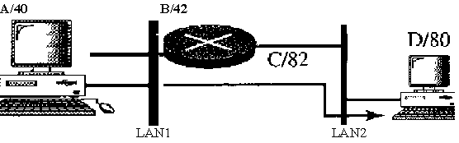 | [2]  [3]
4. | Discuss the functionalities of the OSI user support layers. | [5]
PART – B (3 X 10 = 30 Marks)
Answer ALL Questions
5. | a) Explain the design goals of ATM and the cell header that is used outside the ATM network.  b) Multiplexing is more efficient if all the data units are the same size. Justify. | [8]  [2]
6.  7. | a) What are the basic important layers required to establish communication between two devices? Explain them.  b) Differentiate logical, physical, and port addresses with example.  Illustrate the switching technique that is used in Frame Relay and ATM Network. | [5]  [5]  [10]

